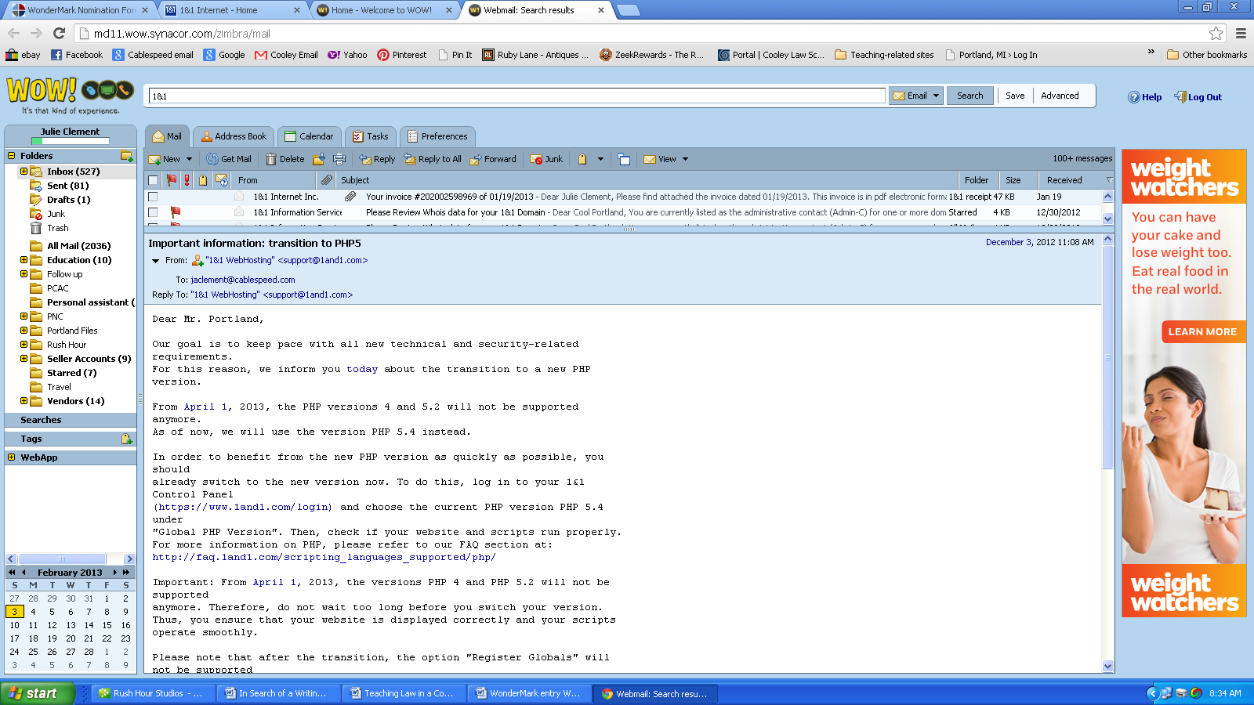

Dear Mr. Portland,
Our goal is to keep pace with all new technical and security-related
requirements.
For this reason, we inform you today about the transition to a new PHP
version.
From April 1, 2013, the PHP versions 4 and 5.2 will not be supported
anymore.
As of now, we will use the version PHP 5.4 instead.
In order to benefit from the new PHP version as quickly as possible, you
should
already switch to the new version now. To do this, log in to your 1&1
Control Panel
(https://www.1and1.com/login) and choose the current PHP version PHP 5.4
under
"Global PHP Version". Then, check if your website and scripts run properly.
For more information on PHP, please refer to our FAQ section at:
http://faq.1and1.com/scripting_languages_supported/php/
Important: From April 1, 2013, the versions PHP 4 and PHP 5.2 will not be
supported
anymore. Therefore, do not wait too long before you switch your version.
Thus, you ensure that your website is displayed correctly and your scripts
operate smoothly.
Please note that after the transition, the option "Register Globals" will
not be supported
anymore. Furthermore, we recommend updating the following applications in
particular:
- Contao
- Drupal
- eGroupWare
- Joomla
- MediaWiki
- myorgbook
- osCommerce
- phpBB
- Serendipity
- Shopware
- Typo3
- WebCalendar
- WordPress
- XOOPS
- xt:Commerce
Do you have any further questions?
Please feel free to call us. Our team will be pleased to support you - 7
days a week,
24 hours a day: 1 - 866 - 991 - 2631
Or send an e-mail to: support@1and1.com
We wish you a lot of success with your new PHP version!
Yours sincerely,
Web Hosting Team
1&1 Internet Inc.

