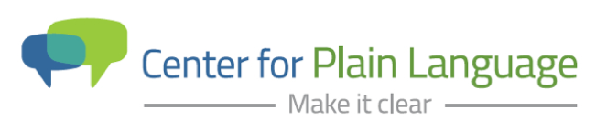

Center for Plain Language to host Spring Workshop
David Berman to Present Website Accessibility Workshop on May 10, 2016

WASHINGTON, D.C., April 7, 2016 – The Center for Plain Language will host their Spring 2016 Workshop featuring internationally renowned design and communication expert David Berman. The New Standard on Accessibility: Leaving No Content Behind Online workshop will be presented at the National Press Club in Washington, D.C. in the afternoon on Tuesday, May 10, 2016 prior to the ClearMark Awards ceremony that evening.

David Berman has over 30 years experience with website design and has worked extensively in e-accessibility and inclusive interface design. The New Standard on Accessibility workshop will share best practices in e-accessibility and discuss how to make websites more accessible by complying with current standards and guidelines. Topics include:
- Why accessibility matters to everyone, not just people with disabilities
- Which disabilities are helped by accessible design
- How assistive technologies work
- How accessibility helps your bottom line
- Which regulations apply to accessibility

“From the content to the design to how a website works, accessibility is a critical component of communicating online,” said Susan Kleimann, PhD, Chair, Center for Plain Language. “We are thrilled to have David Berman lead our Spring Workshop. He has a deep understanding of accessibility issues and we are very excited to have him share his insights with plain language enthusiasts.”

David Berman is the author of Do Good Design: How Design Can Change Our World. David is an Invited Expert to the World Wide Web Consortium (W3C), the publishers of the Web Content Accessibility Guidelines (WCAG) for e-accessibility. His work includes award-winning projects in the application of plain language, typeface design, and the development of a system to republish the laws of Canada in plain writing and design.

For more information and to register, visit Center for Plain Language Spring 2016 Workshop.

The Center for Plain Language's mission is to champion clear communication so people and organizations can thrive. The Center's vision is to create a culture of clarity. Every audience. Every format. Every time. For more information and to become a member, visit: centerforplainlanguage.org.

Media Contact: Diane Chojnowski, diane@centerforplainlanguage.org 641-919-0385

