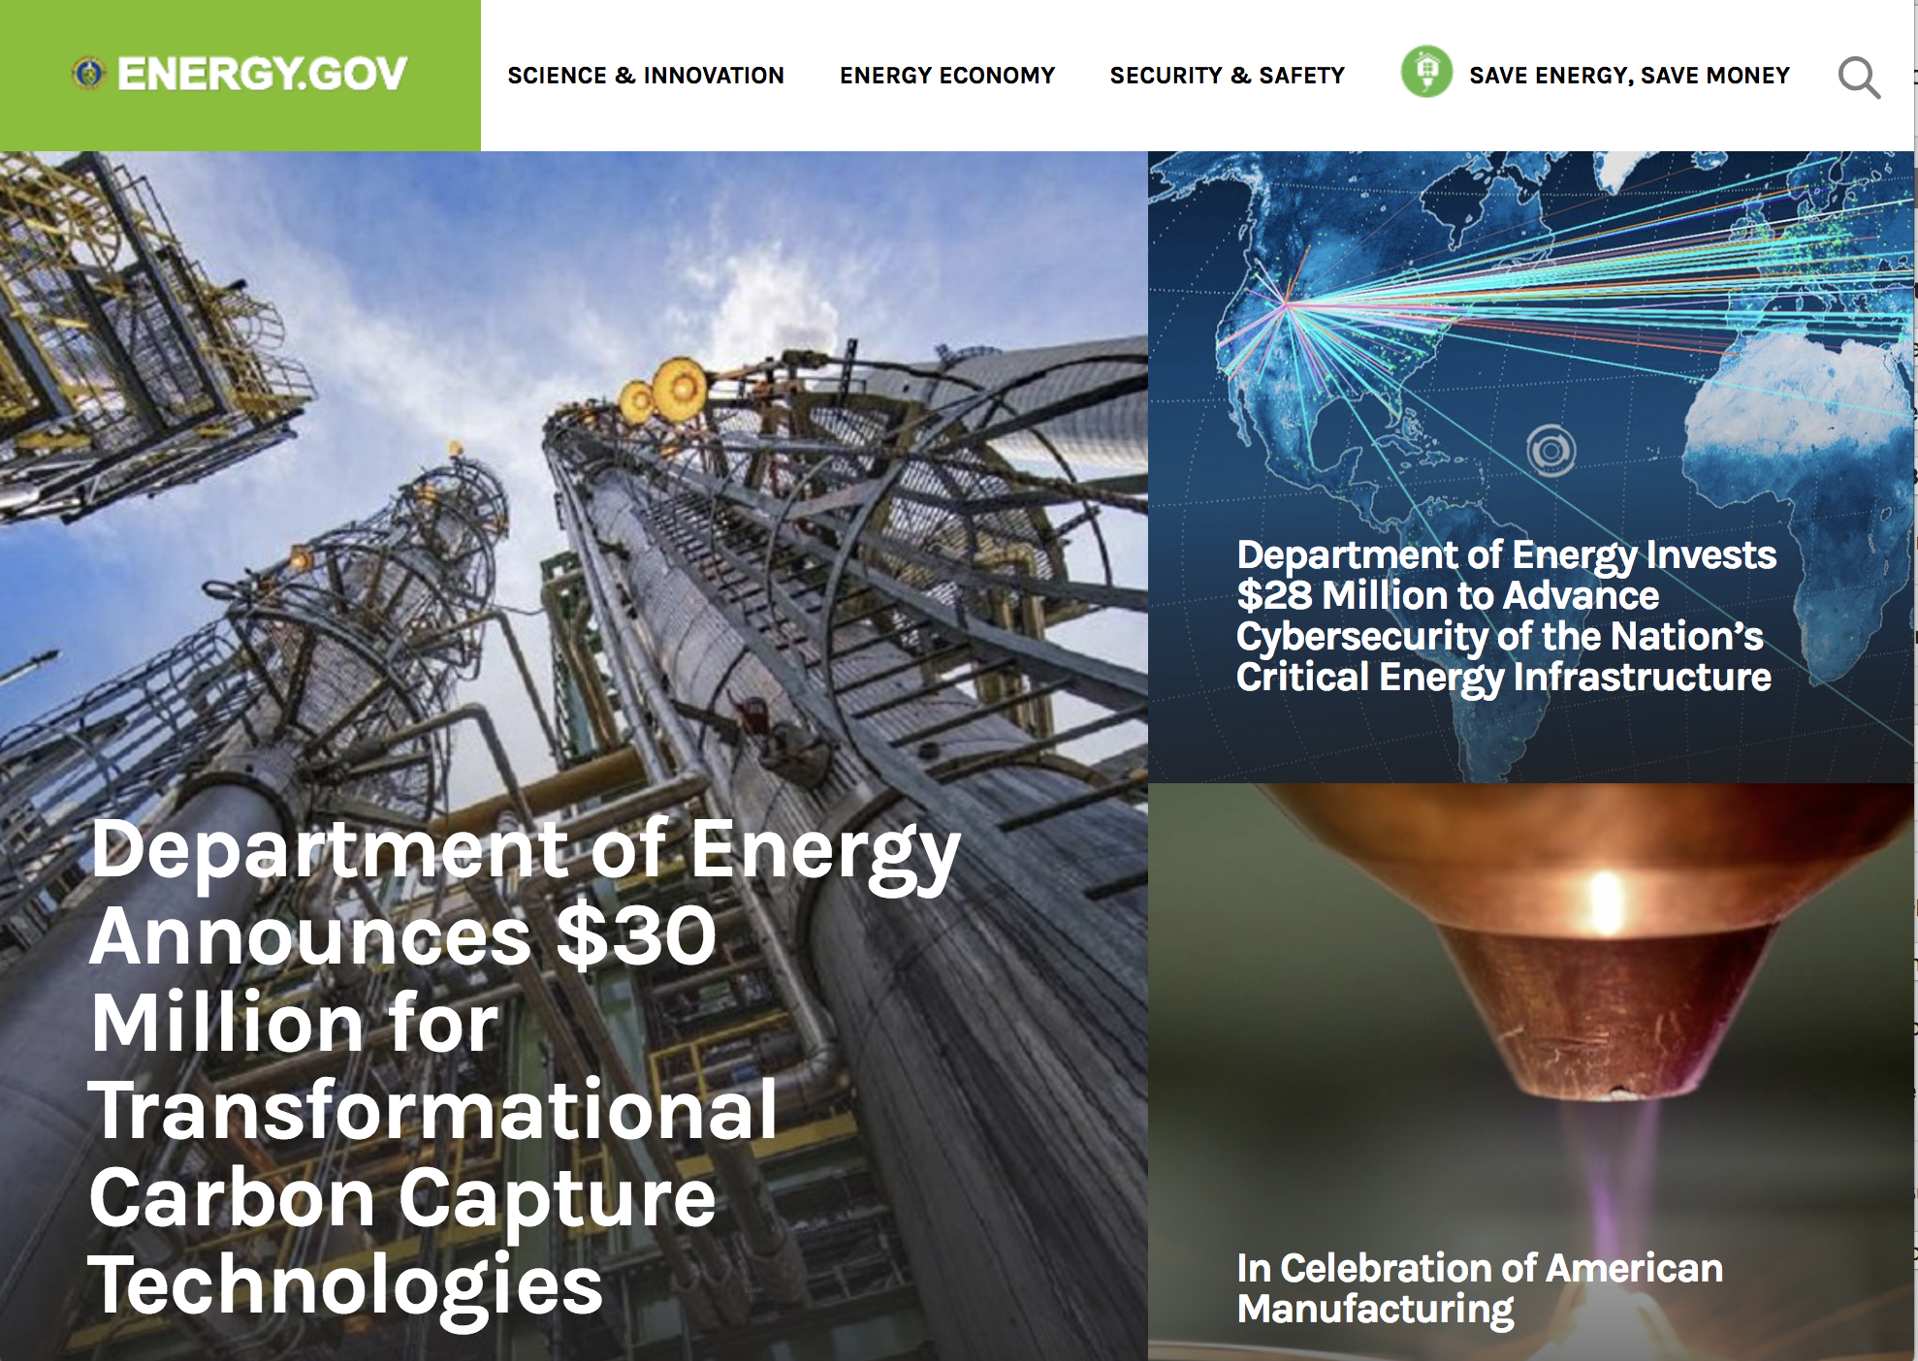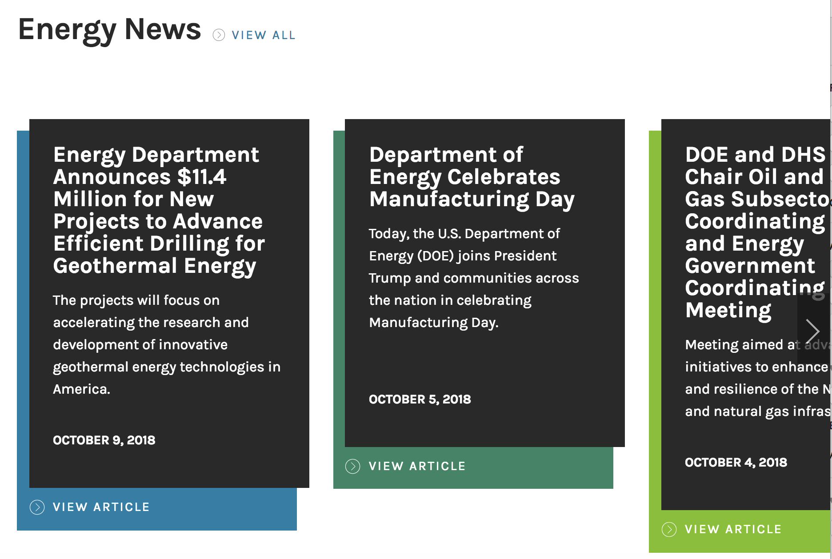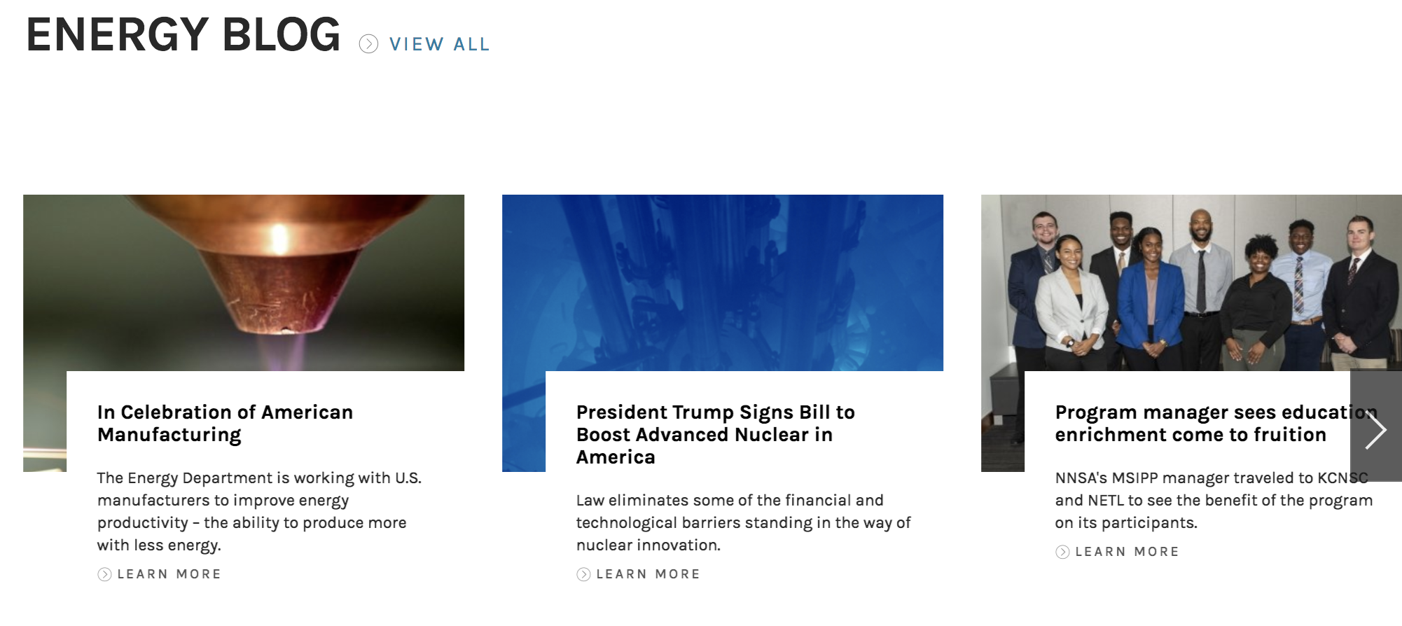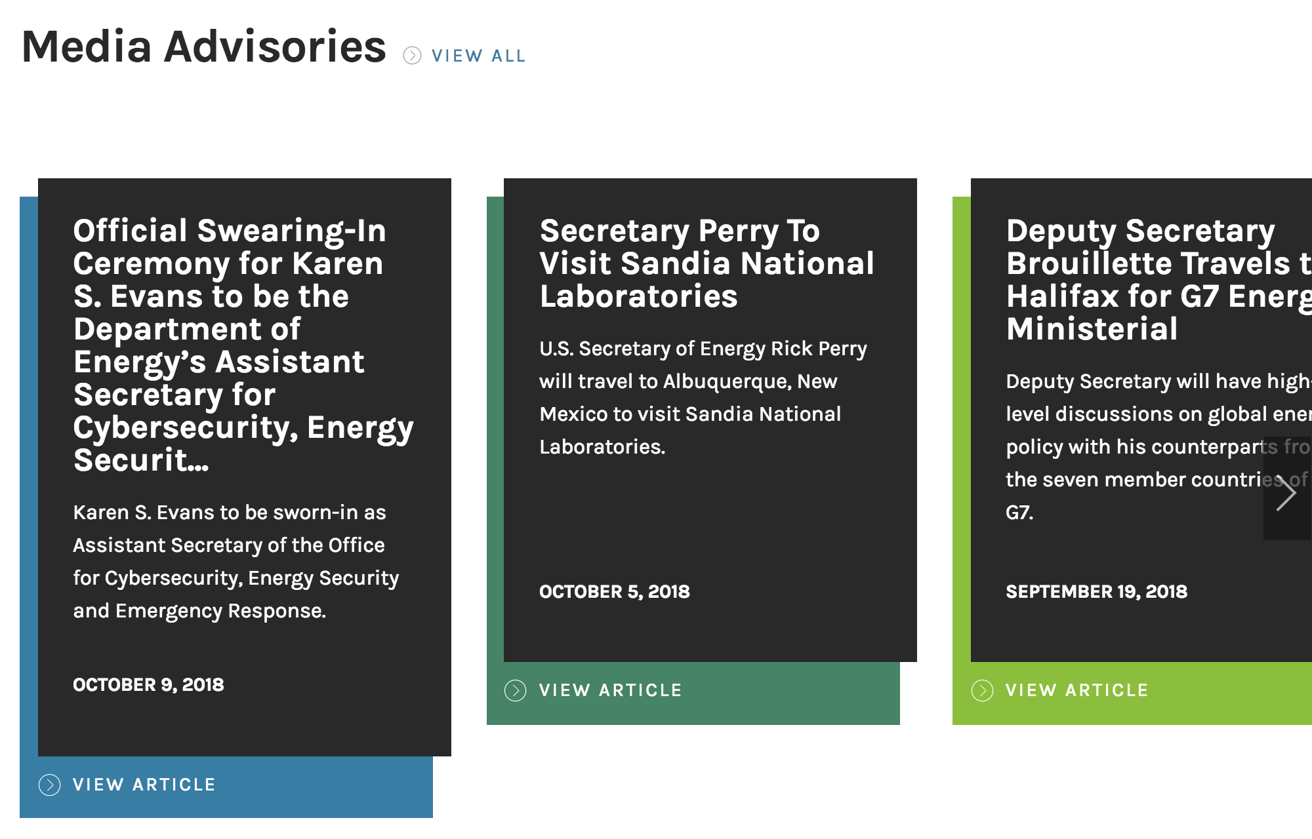

A homepage that needs work

**All about the Department.** According to Department of Energy staff, this homepage is aimed at the public — including scientists, consumers, and entrepreneurs — who come to this page to learn about energy programs and technologies, to seek funding, and to save energy and money. Unfortunately, the page is not designed or written to help them do these things. It’s all about the Department, from top to bottom.

**The Department as subject.** Of the 10 headlines visible in this screenshot, the Department is the grammatical subject in five, the president in one, and Department Secretaries in three. Nowhere will you find public scientists, consumers or entrepreneurs, nor any verbs about what they can do or find. The words “you” and “your” do not appear. Instead, jargon such as “resilience” and subsector appear prominently.

This tiny menu heading is the only text that addresses a user.

The one item that’s of human interest is more appropriate for an internal intranet. Few outside the Department of Energy could translate this sentence: “NNSA’s MSIPP manager traveled to KCNS and NETL to see the benefit of the program on its participants.”

Judge’s comment:

*“While the page shows an updated design, the content is still very old-fashioned, focusing on news of the agency and the agency's administration. The news is all about DOE does this and DOE does that and our Secretary does this and that- not about what the agency's clients are doing or what they need from the agency's website.”*

Judge’s comment:

*“As a fan of DOE and a longtime veteran and manager of federal communications shops, I'm disappointed because I know DOE can do better. ”*